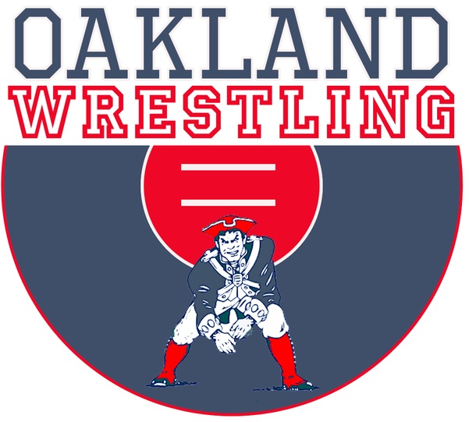

Oakland High School Wrestling

Your tax-deductible donations help to provide the essentials needed by the Team that are not paid for by the school. These expenses include uniforms, tournament fees, referee fees, diesel gas, bus drivers, uniforms, mat tape, saving for a new mat. Donations of any amount are appreciated! Please make all checks payable to
“Oakland Wrestling” and mail to:

Oakland Wrestling
2225 Patriot Dr
Murfreesboro, TN 37130

You may also send in your donation with the Oakland High Wrestler that you are donating to.
Please keep the top portion of this form as your receipt for supporting Oakland Wrestling.
Thanks again for your support!

Donation Amount $____________
--------------------------------------------------------------------------------------------------------------------------
Please Return This Portion With Your Donation
Wrestlers Name__________________________ Your Email________________________
Business Name___________________________ Contact Name______________________
Address_________________________________
Shirt Size: _________________________ -Please Specify (t-shirt, polo, hoody)

____Super Patriot partnership - $1000
- Business name/logo on the Oakland Wrestling website sponsor page.
- Business name/logo on the OHS sponsor banner that will be displayed at all home wrestling matches.
- Business name/logo will be displayed on the video board in the gym for all home wrestling matches.
- 2 Courtesy passes to all home wrestling matches.
- Choice Oakland wrestling T-shirt, Polo, Hoody, or ¼ zip shirt.
____Patriot partnership - $500
- Business name/logo on the Oakland Wrestling web site sponsor page.
- Business name/logo on the OHS sponsor banner that will be displayed at all home wrestling matches.
- Business name/logo will be displayed on the video board in the gym for all home wrestling matches.
- Oakland Wrestling Supporter shirt
____Friends of OHS Wrestling - $100
- Business name/logo on the Oakland Wrestling web site sponsor page
_____ $50 Sponsorship
_____ Other amount $_______

Email logo/artwork to: harrisj@rcschools.net - logo/artwork for Super Patriot banner due 11-15-21
Contact: Josh Harris, Oakland High School Head Wrestling Coach, 615-414-4213
Thank You for supporting Oakland Wrestling! Strengthening Character through Sports!

